**DATE: 03-10-2021**

**RJ SHOES (ONLINE PURCHASE)**

**BY**

**RAJA M**

**ONLINE SHOPPING (SHOES)**

**INTRODUCTION**

* **The name of the projects is RJ Shoes**
* **This documents provides the details of the project online shoes**
* **The purpose of the project is to provides easy shopping facility online for the shoes**

**Project Properties**

1. **Netbeans 8.2**
2. **HTML, CSS**
3. **Java, Database**

**ADMIN PAGE.JSP**

<%--

Document : AdminPage

Created on : Aug 30, 2021, 3:42:02 PM

Author : RAJA M

--%>

<%@page contentType="text/html" pageEncoding="UTF-8"%>

<!DOCTYPE html>

<html>

<jsp:include page="header1.jsp"></jsp:include>

<jsp:include page="Template.jsp"></jsp:include>

<head>

<meta http-equiv="Content-Type" content="text/html; charset=UTF-8">

<title>RJ Shoes</title>

</head>

<body>

<center>

<form action="AdminLogin.jsp" method="POST">

<table style="border: solid peru; border-spacing: 15px; opacity: 1; background-color: gold">

<tr><td>

<h3 style="color: blue">Admin Login</h3><br>

<div align="right">

<input type="text" name="user" id="userid" value="" autofocus="" required="" placeholder="Admin Name"/><br/><br/>

<input type="password" name="pass" value="" required="" placeholder="Password"/><br/><br/></div>

<div align="center">

<input type="submit" value="Submit" style="background-color: #3399ff; color: white; border-radius: 4px"/></div><br><br>

</td></tr></table>

</form><br/>

</center>

</body>

</html>

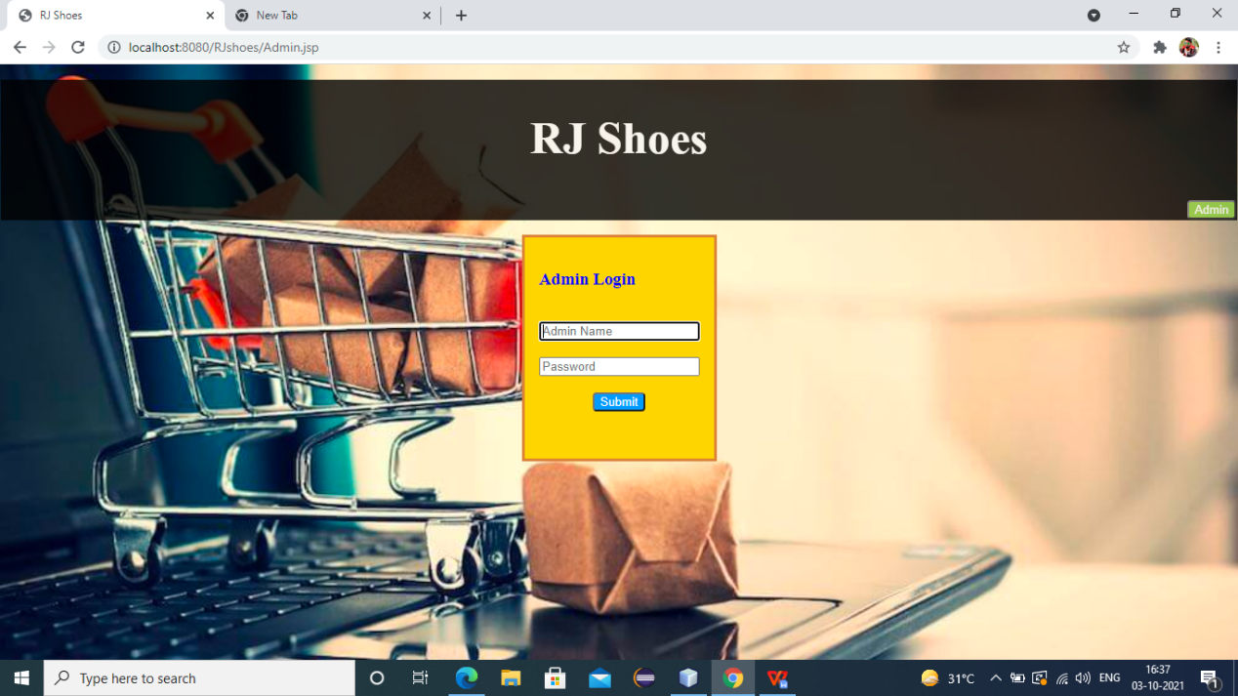

**ADMINLOGIN.JSP**

<%--

Document : AdminLogin

Created on : Sep 19, 2021, 8:28:13 PM

Author : RAJA M

--%>

<%@page contentType="text/html" pageEncoding="UTF-8"%>

<!DOCTYPE html>

<html>

<jsp:include page="header1.jsp"></jsp:include>

<jsp:include page="Template.jsp"></jsp:include>

<head>

<meta http-equiv="Content-Type" content="text/html; charset=UTF-8">

<title>RJ Shoes</title>

</head>

<body style="background-color: gold;">

<div align="left">

<a href="Adminreg.jsp" style="color: red">Add Admin</a><br><br>

</div>

<div align="center">

<h2>WELCOME ADMIN</h2>

</div>

<a href="Database">CLICK</a>

</body>

</html>

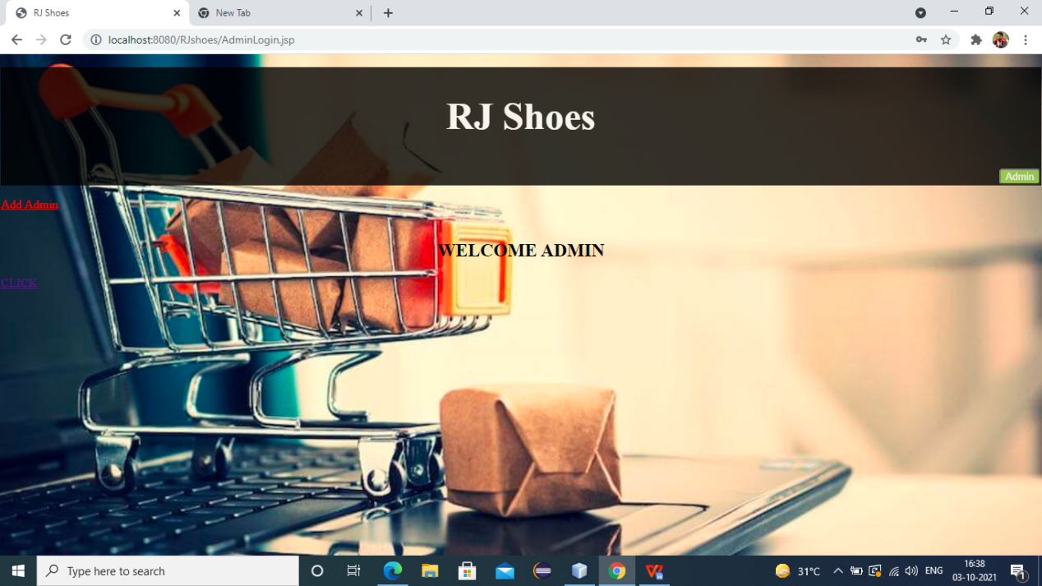

**ADMINREG.JSP**

<%--

Document : Adminreg

Created on : Sep 12, 2021, 6:32:23 AM

Author : RAJA M

--%>

<%@page contentType="text/html" pageEncoding="UTF-8"%>

<!DOCTYPE html>

<html>

<jsp:include page="header1.jsp"></jsp:include>

<jsp:include page="Template.jsp"></jsp:include>

<head>

<meta http-equiv="Content-Type" content="text/html; charset=UTF-8">

<title>RJ Shoes</title>

</head>

<body>

<center>

<form action="Adminregdao" method="post">

<table style="border: solid gold; border-spacing: 18px; width: 17%; opacity: 1; background-color: gold">

<tr><td>

<h3 style="color: blue">Admin Registration</h3><br>

Admin Name:<br><input type="text" name="username" value="" required="" autofocus=""/><br><br/>

E-Mail:<br/><input type="text" name="email" value="" required="" /><br/><br/>

Password:<br><input type="password" name="npass" value="" required=""/><br><br>

Retype Password:<br><input type="password" name="rpass" value="" required=""/><br><br>

Designation:<br><input type="text" name="desig" value="" /><br><br>

Phone:<br><input type="text" name="phone" value="" /><br><br>

<input type="submit" value="Submit" style="background-color: #3399ff; color: white; border-radius: 4px" />&nbsp;&nbsp;

<input type="reset" value="Reset" style="background-color: #3399ff; color: white; border-radius: 4px"/>

</td></tr>

</table>

</form>

<br>

<button style="color: gray"><a href="Admin.jsp" style="color: blueviolet">Admin Page</a></button>

</center>

</body>

</html>

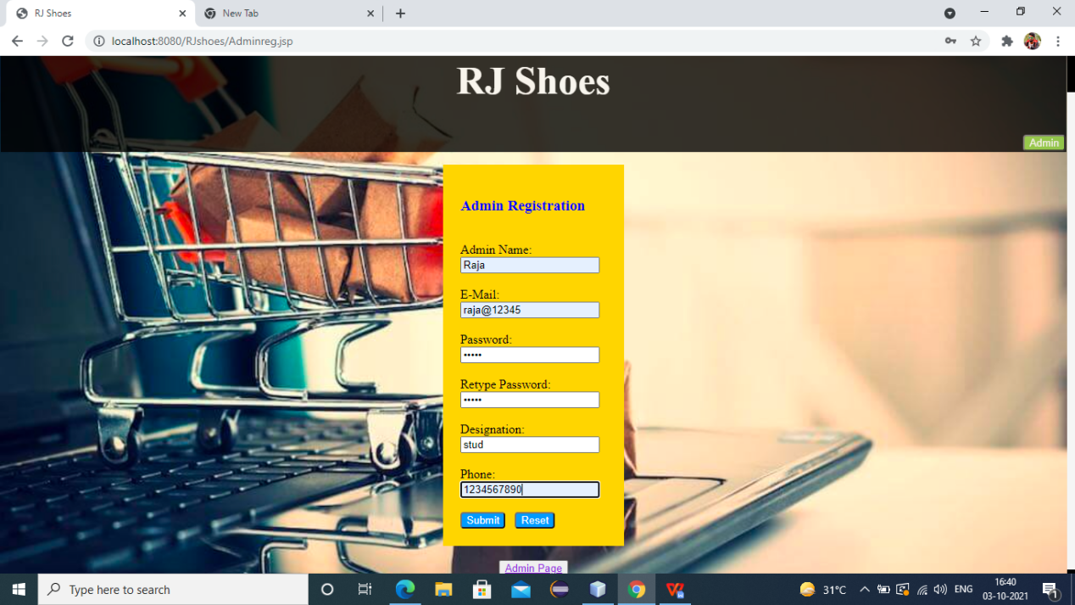

**LOGINPAGE.JSP**

<%--

Document : LoginPage

Created on : Aug 30, 2021, 3:41:31 PM

Author : RAJA M

--%>

<%@page contentType="text/html" pageEncoding="UTF-8"%>

<!DOCTYPE html>

<html>

<jsp:include page="header1.jsp"></jsp:include>

<jsp:include page="Template.jsp"></jsp:include>

<head>

<meta http-equiv="Content-Type" content="text/html; charset=UTF-8">

<title>RJ Shoes</title>

</head>

<body>

<center>

<form action="Logindao" method="POST">

<table style="border: solid seashell; border-spacing: 15px; opacity: 1; background-color: seashell">

<tr><td>

<h3 style="color: blue">Customer Login</h3><br>

<div align="right">

<input type="text" name="user" id="userid" value="" onkeyup="validate()" autofocus="" required="" placeholder="UserName"/><br/><br/>

<input type="password" name="pass" value="" required="" placeholder="Password"/><br/><br/></div>

<div align="center">

<input type="submit" value="Submit" style="background-color: #3399ff; color: white; border-radius: 4px"/>

</div><br><br>

<a href="Registration.jsp" style="color: red">Create Account</a><br/><br/>

</td></tr></table>

</form><br/>

</center>

</body>

<%@include file="footer.jsp"%>

</html>

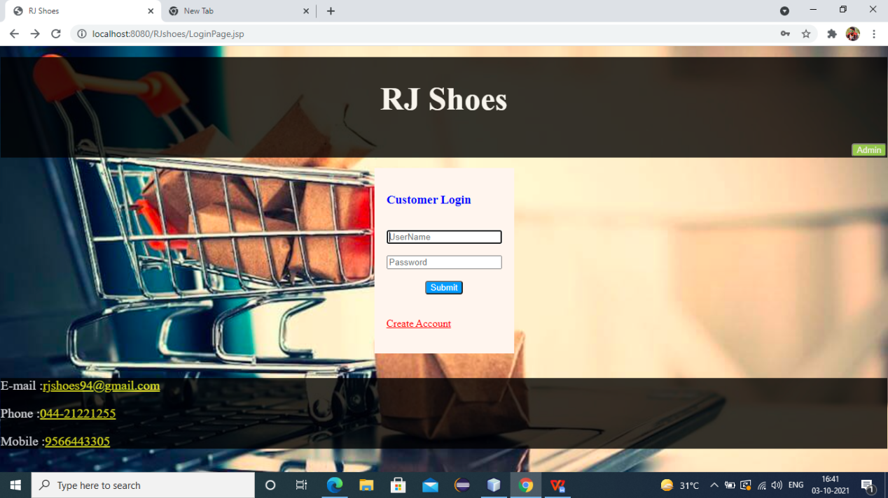

**REGISTRATION.JSP**

<%--

Document : Registration

Created on : Sep 1, 2021, 11:33:32 AM

Author : RAJA M

--%>

<%@page contentType="text/html" pageEncoding="UTF-8"%>

<!DOCTYPE html>

<html>

<jsp:include page="header1.jsp"></jsp:include>

<jsp:include page="Template.jsp"></jsp:include>

<head>

<meta http-equiv="Content-Type" content="text/html; charset=UTF-8">

<title>RJ Shoes</title>

</head>

<body>

<center>

<form action="registrationdao" method="post">

<table style="border: solid seashell; border-spacing: 18px; width: 17%; opacity: 1; background-color: seashell">

<tr><td>

<h3 style="color: blue">Customer Registration</h3><br>

<div style="color: blue">

User Name:<br><input type="text" name="username" value="" required="" autofocus=""/><br><br/>

E-Mail:<br/><input type="text" name="email" value="" required="" /><br/><br/>

Password:<br><input type="password" name="npass" value="" required=""/><br><br>

Retype Password:<br><input type="password" name="rpass" value="" required=""/><br><br>

Address:<br><textarea name="Address" rows="2" cols="20" required="">

</textarea><br><br>

State:<br><input type="text" name="State" value="" required=""/><br><br>

Phone:<br><input type="text" name="phone" value="" /><br><br>

</div>

<input type="submit" value="Submit" style="background-color: #3399ff; color: white; border-radius: 4px" />&nbsp;&nbsp;

<input type="reset" value="Reset" style="background-color: #3399ff; color: white; border-radius: 4px"/>

</td></tr>

</table>

</form>

<br>

<button style="color: gray"><a href="LoginPage.jsp" style="color: blueviolet">Go Back To Login Page</a></button>

</center>

<br><br>

</body>

<jsp:include page="footer.jsp"></jsp:include>

</html>

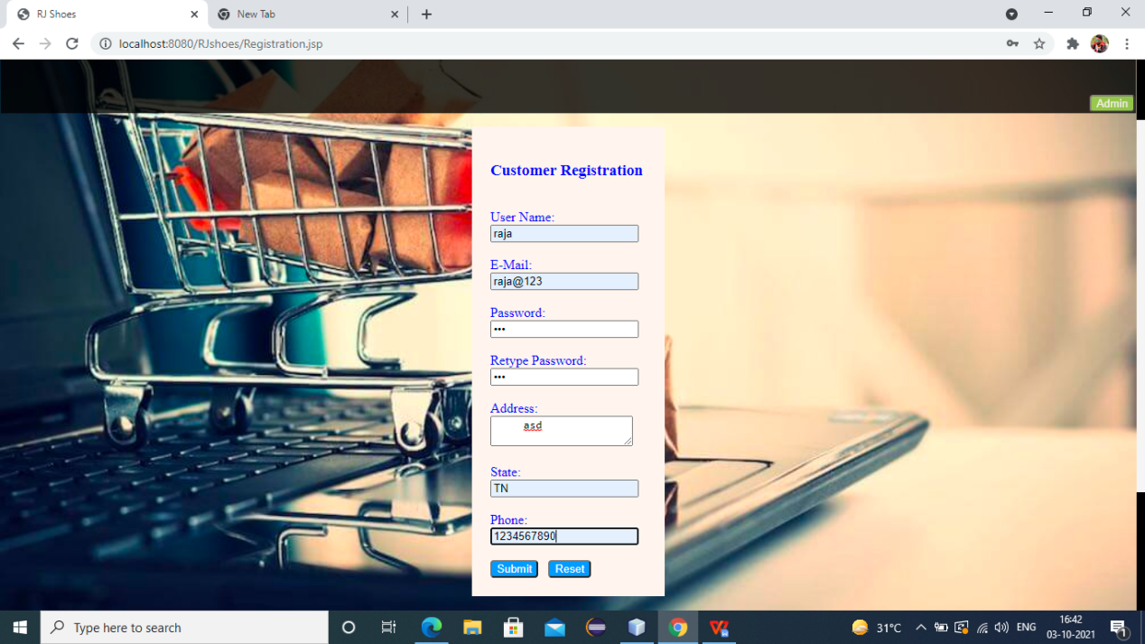

**WELCOMECUSTOMER.JSP**

<%--

Document : WelcomeCostumer

Created on : Aug 31, 2021, 12:32:06 PM

Author : RAJA M

--%>

<%@page contentType="text/html" pageEncoding="UTF-8"%>

<!DOCTYPE html>

<html>

<jsp:include page="header.jsp"></jsp:include>

<jsp:include page="Template.jsp"></jsp:include>

<head>

<meta http-equiv="Content-Type" content="text/html; charset=UTF-8">

<title>RJ Shoes</title>

<style>

.nav{

list-style-type: none;

text-align: left;

margin: 0;

padding: 0;

}

.nav li{

display: inline-block;

padding: 20px;

}

</style>

</head>

<body>

<div align="center">

<table style="background-color: seashell"><tr><td>

<ul class="nav">

<li><a href="Nike.jsp"><img src="Images/Nike/MainImage.jpeg" width="100" height="100" alt="img 1"><br/><h4 style="color: darkorange">Nike</h4></h4></a><br/></li>

<li><a href="Reebok.jsp"><img src="Images/Reebok/MainImage.jpg" width="100" height="100" alt="img 2"><br/><h4 style="color: darkorange">Reebok</h4></a><br/></li>

<li><a href="Adidas.jsp"><img src="Images/Adidas/Mainimage.jpg" width="100" height="100" alt="img 3"><br/><h4 style="color: darkorange">Adidas</h4></a><br/></li>

</ul>

</td></tr></table>

</div>

</body>

<br><br><br><br><br><br>

<jsp:include page="footer.jsp"></jsp:include>

</html>

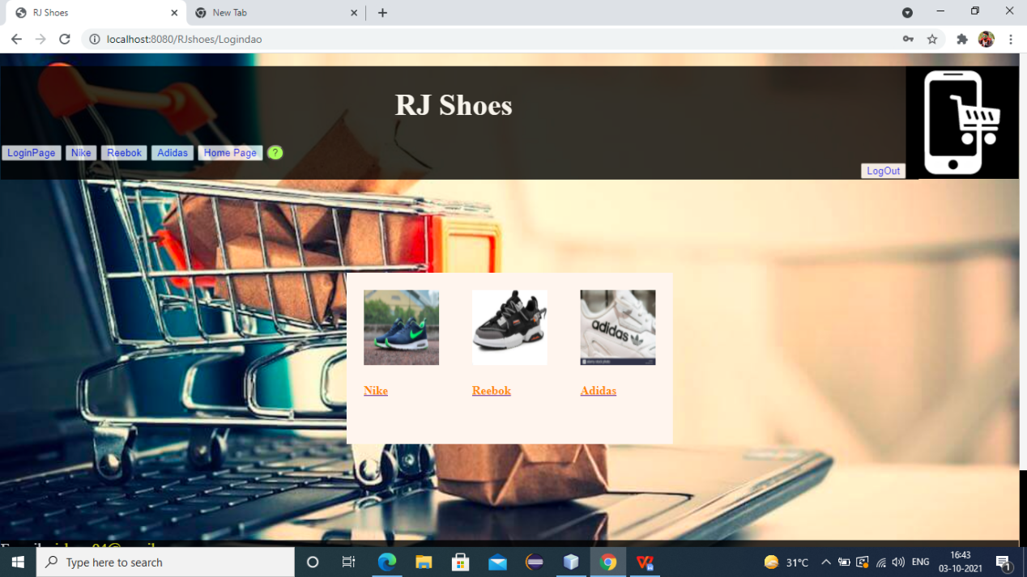

**NIKE.JSP**

<%--

Document : Nike

Created on : Sep 1, 2021, 10:32:04 AM

Author : RAJA M

--%>

<%@page contentType="text/html" pageEncoding="UTF-8"%>

<%@taglib prefix="c" uri="http://java.sun.com/jsp/jstl/core"%>

<!DOCTYPE html>

<html>

<jsp:include page="header.jsp"></jsp:include>

<jsp:include page="Template.jsp"></jsp:include>

<head>

<meta http-equiv="Content-Type" content="text/html; charset=UTF-8">

<title>RJ Shoes</title>

</head>

<body>

<center>

<form action='<c:url value="/SessionServlet"/>' name="myform" method="post">

<table style="border: none; border-spacing: 50px; background-color: darkorange; opacity: 0.7"><tr>

<td><img src='Images/Nike/Nike1.jpg' name="nike" value="Royal" width='100' height='100'/>

<details><c:set var="Royal" value="1400"/>Price : <c:out value="${Royal}"/><br>

<c:set var="Royal" value="Royal"/>Name : <c:out value="${Royal}"/></details><br/></td>

<td><img src='Images/Nike/Nike2.jpg' name="nike" value="Cut" width='100' height='100' />

<details><c:set var="Cut" value="1500"/>Price : <c:out value="${Cut}"/><br>

<c:set var="Cut" value="Cut"/>Name : <c:out value="${Cut}"/></details><br/></td>

<td><img src='Images/Nike/Nike3.jpeg' name="nike" value="Widow" width='100' height='100'/>

<details><c:set var="Widow" value="1600"/>Price : <c:out value="${Widow}"/><br>

<c:set var="Widow" value="Widow"/>Name : <c:out value="${Widow}"/></details><br/></td>

<td><img src='Images/Nike/Nike4.jpg' name="nike" value="Classic" width='100' height='100'/>

<details><c:set var="Classic" value="1700"/>Price : <c:out value="${Classic}"/><br>

<c:set var="Classic" value="Classic"/>Name : <c:out value="${Classic}"/></details><br/></td>

<td><img src='Images/Nike/Nike5.jpg' name="nike" value="Modern" width='100' height='100'/>

<details><c:set var="Modern" value="1800"/>Price : <c:out value="${Modern}"/><br>

<c:set var="Modern" value="Modern"/>Name : <c:out value="${Modern}"/></details><br/></td>

</tr></table></form>

<br><br><br><br><br>

<form action='<c:url value="/SessionServlet"/>' name='MyForm' method='POST'>

<table style="border: solid seashell; border-spacing: 15px; opacity: 1; background-color: seashell"> <tr>

<td bordercolor='white'><font color='darkorange'> Select Item From Above : </font></td>

<td bordercolor='white'>

<select name='nike'>

<option value='Royal'>Royal</option>

<option value='Cut'>Cut</option>

<option value='Widow'>Widow</option>

<option value='Classic'>Classic</option>

<option value='Modern'>Modern</option>

</select>

<tr>

<td bordercolor='white'><font color='darkorange'> Number of Shoes : </font> </td>

<td bordercolor='white'>

<input type= 'text' name='numOfNikes' required="" autofocus=""></td> </tr> <tr><td allign="center">

<font color='darkorange'>Delivery Address : </font><br><textarea name="Delivery Address" rows="3" cols="20" required=""></textarea><br/><br/>

<input type='hidden' value='ynike' name='PageName'/> </td> </tr> <tr>

<td bordercolor='white'>

<input type='submit' Value='Next'></input></td>

</tr></table></form>

</center>

</body>

<jsp:include page="footer.jsp"></jsp:include>

</html>

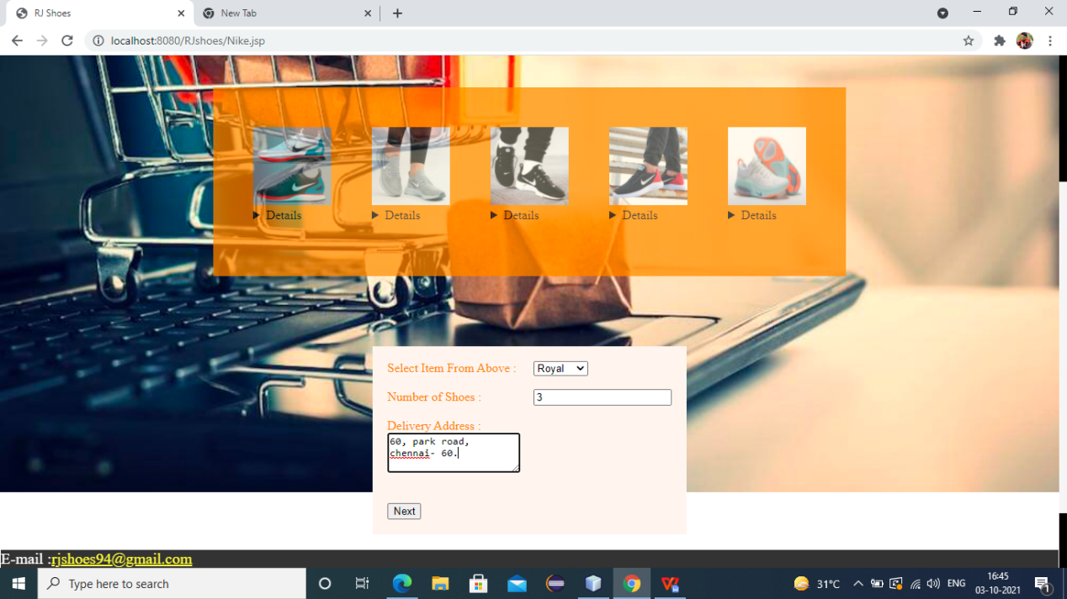

**NIKEDETAILS.JSP**

<%--

Document : Nikedetails

Created on : Sep 1, 2021, 4:42:08 PM

Author : RAJA M

--%>

<%@taglib prefix="c" uri="http://java.sun.com/jsp/jstl/core" %>

<%@page contentType="text/html" pageEncoding="UTF-8"%>

<%@taglib prefix="fmt" uri="http://java.sun.com/jsp/jstl/fmt" %>

<!DOCTYPE html>

<html>

<jsp:include page="header.jsp"></jsp:include>

<jsp:include page="Template.jsp"></jsp:include>

<head>

<meta http-equiv="Content-Type" content="text/html; charset=UTF-8">

<title>RJ Shoes</title>

</head>

<body>

<center>

<form action="OrderPlaced.jsp" method="post">

<table style="color: black; border: 3px solid; width: 300px; height: 160px; background-color: seashell" ><tr><td>

<input type="radio" name="bt" value="cash" checked="checked" />Cash On Delivery<br>

<input type="radio" name="bt" value="online" disabled="disabled" /> Online payment<br/><br/>

</td></tr>

<c:set var="nike" value="${sessionScope.selnike}"/>

<c:set var="NumberOfnikes" value="${numnikes}"/>

<c:choose>

<c:when test="${nike=='Royal'}">

<c:set var="Price" value="1400"/>

</c:when>

<c:when test="${nike=='Cut'}">

<c:set var="Price" value="1500"/>

</c:when>

<c:when test="${nike=='Widow'}">

<c:set var="Price" value="1600"/>

</c:when>

<c:when test="${nike=='Classic'}">

<c:set var="Price" value="1700"/>

</c:when>

<c:when test="${nike=='Modern'}">

<c:set var="Price" value="1800"/>

</c:when>

</c:choose>

<tr><td bordercolor='white'>Nike : <td colspan="2"><c:out value="${nike}"/> </td><br>

<br>

<tr><td bordercolor='Black'>Number Of Shoes : <td colspan="2"><c:out value="${NumberOfnikes}"/></td> <br>

<tr><td bordercolor='Black'>Total Price: <td colspan="2"><b><fmt:formatNumber pattern="₹##,##,###.##" value="${Price*NumberOfnikes}"/></b></td><br><br/>

<tr>

<td><input type="submit" value="Submit" /></td></tr>

</table>

</form>

</center>

<h3>Please Read the Terms And Conditions Before Submit</h3>

<a href="Terms.jsp"><h3 style="color: blue">*Terms And Conditions</h3></a>

</body>

<jsp:include page="footer.jsp"></jsp:include>

</html>

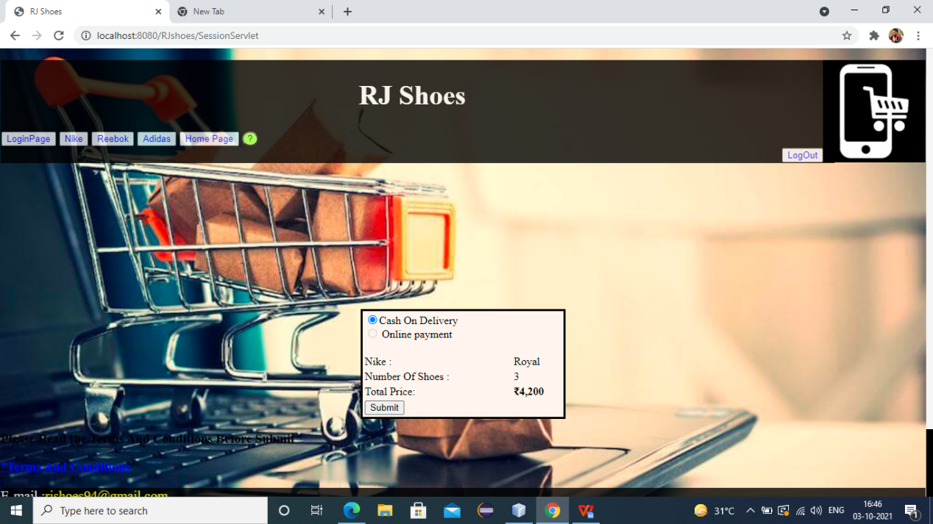

**REEBOK.JSP**

<%--

Document : reebok

Created on : Sep 1, 2021, 10:38:34 AM

Author : RAJA M

--%>

<%@page contentType="text/html" pageEncoding="UTF-8"%>

<%@taglib prefix="c" uri="http://java.sun.com/jsp/jstl/core"%>

<!DOCTYPE html>

<html>

<jsp:include page="header.jsp"></jsp:include>

<jsp:include page="Template.jsp"></jsp:include>

<p style="color: red" id="demo"></p>

<head>

<meta http-equiv="Content-Type" content="text/html; charset=UTF-8">

<title>RJ Shoes</title>

</head>

<body>

<center>

<p id="help" style="display: none">Select a Reebok From Below</p>

<form action='<c:url value="/SessionServlet"/>' name="myform" method="post">

<table style="border: none; border-spacing: 50px; background-color: whitesmoke; opacity: 0.8"><tr>

<td><img src='Images/Reebok/Reebok1.jpeg' name="reebok" value="Cotton" width='100' height='100'/>

<details><c:set var="Cotton" value="1100"/>Price : <c:out value="${Cotton}"/><br>

<c:set var="Cotton" value="Cotton"/>Name : <c:out value="${Cotton}"/></details><br/></td>

<td><img src='Images/Reebok/Reebok2.jpg' name="reebok" value="Rocks" width='100' height='100' />

<details><c:set var="Rocks" value="1200"/>Price : <c:out value="${Rocks}"/><br>

<c:set var="Rocks" value="Rocks"/>Name : <c:out value="${Rocks}"/></details><br/></td>

<td><img src='Images/Reebok/Reebok3.jpg' name="reebok" value="Trumph" width='100' height='100'/>

<details><c:set var="Trumph" value="1300"/>Price : <c:out value="${Trumph}"/><br>

<c:set var="Trumph" value="Trumph"/>Name : <c:out value="${Trumph}"/></details><br/></td>

<td><img src='Images/Reebok/Reebok4.jpg' name="reebok" value="Horse" width='100' height='100'/>

<details><c:set var="Horse" value="1400"/>Price : <c:out value="${Horse}"/><br>

<c:set var="Horse" value="Red Trumph"/>Name : <c:out value="${Horse}"/></details><br/></td>

<td><img src='Images/Reebok/Reebok5.jpg' name="reebok" value="FootSprint" width='100' height='100'/>

<details><c:set var="FootSprint" value="1500"/>Price : <c:out value="${FootSprint}"/><br>

<c:set var="FootSprint" value="FootSprint"/>Name : <c:out value="${FootSprint}"/></details><br/></td>

<td><img src='Images/Reebok/Reebok6.jpeg' name="reebok" value="Markone" width='100' height='100'/>

<details><c:set var="Markone" value="1600"/>Price : <c:out value="${Markone}"/><br>

<c:set var="Markone" value="Markone"/>Name : <c:out value="${Markone}"/></details><br/></td>

</tr></table></form>

<br><br><br><br><br>

<form action='<c:url value="/SessionServlet"/>' name='MyForm' method='POST'>

<table style="border: solid seashell; border-spacing: 15px; opacity: 1; background-color: seashell"> <tr>

<td bordercolor='white'><font color='darkblue'> Select Item From Above : </font></td>

<td bordercolor='white'>

<select name='reebok'>

<option value='Cotton'>Cotton</option>

<option value='Rocks'>Rocks</option>

<option value='Trumph'>Trumph</option>

<option value='Horse'>Horse</option>

<option value='FootSprint'>FootSprint</option>

<option value='Markone'>Markone</option>

</select>

<tr>

<td bordercolor='white'>Number of Reebok </td>

<td bordercolor='white'>

<input type= 'text' name='numOfReebok' required="" autofocus=""></td> </tr> <tr><td allign="center">

Delivery Address : <br><textarea name="Delivery Address" rows="3" cols="20" required=""></textarea><br/><br/>

<input type='hidden' value='yreebok' name='PageName'/> </td> </tr> <tr>

<td bordercolor='white'>

<input type='submit' Value='Next'></input></td>

</tr></table></form>

</center>

</body>

<jsp:include page="footer.jsp"></jsp:include>

</html>

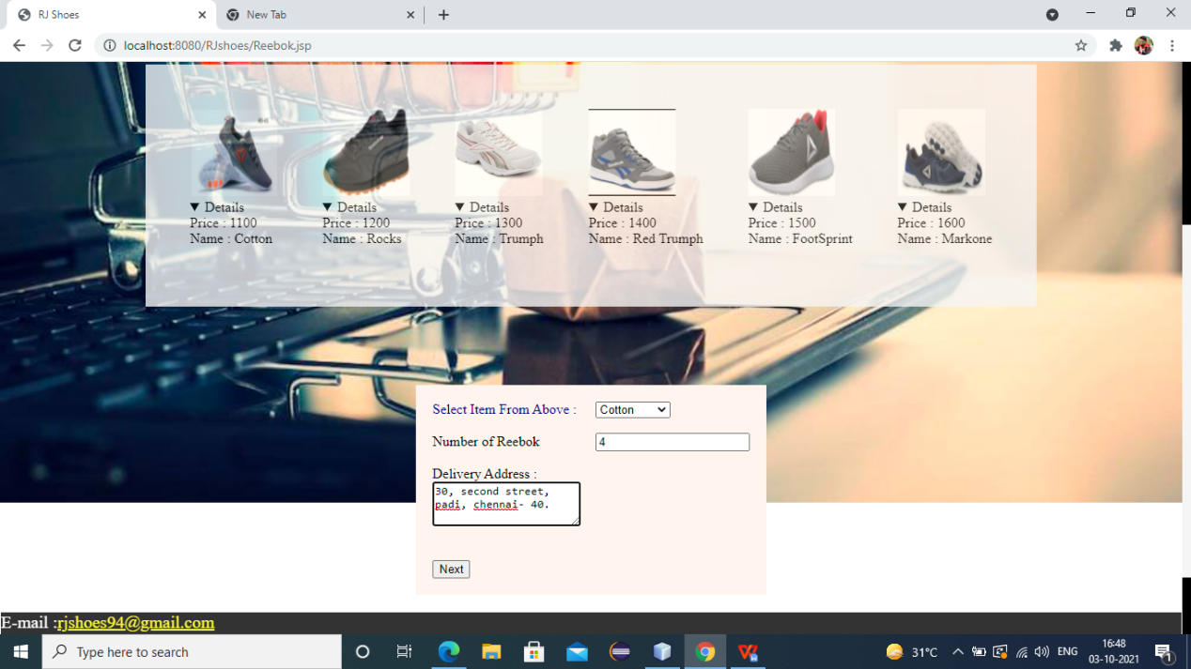

**REBOKDETAILS.JSP**

<%--

Document : Reebokdetails

Created on : Sep 10, 2021, 8:06:44 PM

Author : RAJA M

--%>

<%@page contentType="text/html" pageEncoding="UTF-8"%>

<%@taglib prefix="c" uri="http://java.sun.com/jsp/jstl/core"%>

<%@taglib prefix="fmt" uri="http://java.sun.com/jsp/jstl/fmt" %>

<!DOCTYPE html>

<html>

<jsp:include page="header.jsp"></jsp:include>

<jsp:include page="Template.jsp"></jsp:include>

<head>

<meta http-equiv="Content -Type" content="text/html; charset=UTF-8">

<title>RJ Shoes</title>

</head>

<body>

<center>

<form action="OrderPlaced.jsp" method="post">

<table style="color: black; border: 3px solid; width: 300px; height: 160px; background-color: seashell" ><tr><td>

<input type="radio" name="bt" value="cash" checked="checked" />Cash On Delivery<br>

<input type="radio" name="bt" value="online" disabled="disabled" /> Online payment<br/><br/>

</td></tr>

<c:set var="reebok" value="${sessionScope.selreebok}"/>

<c:set var="NumberOfreebok" value="${numreebok}"/>

<c:choose>

<c:when test="${reebok=='Cotton'}">

<c:set var="Price" value="1100"/>

</c:when>

<c:when test="${reebok=='Rocks'}">

<c:set var="Price" value="1200"/>

</c:when>

<c:when test="${reebok=='Trumph'}">

<c:set var="Price" value="1300"/>

</c:when>

<c:when test="${reebok=='Horse'}">

<c:set var="Price" value="1400"/>

</c:when>

<c:when test="${reebok=='FootSprint'}">

<c:set var="Price" value="1500"/>

</c:when>

<c:when test="${reebok=='Markone'}">

<c:set var="Price" value="1600"/>

</c:when>

</c:choose>

<tr><td bordercolor='white'>Reebok : <td colspan="2"><c:out value="${reebok}"/> </td><br>

<br>

<tr><td bordercolor='Black'>Number Of Shoes : <td colspan="2"><c:out value="${NumberOfreebok}"/></td> <br>

<tr><td bordercolor='Black'>Total Price: <td colspan="2"><b><fmt:formatNumber pattern="₹##,##,###.##" value="${Price*NumberOfreebok}"/></b></td><br><br/>

<tr>

<td><input type="submit" value="Submit"/></td></tr>

</table>

</form>

</center>

<h3>Please Read the Terms And Conditions Before Submit</h3>

<a href="Terms.jsp"><h3 style="color: blue">*Terms And Conditions</h3></a>

</body>

<jsp:include page="footer.jsp"></jsp:include>

</html>

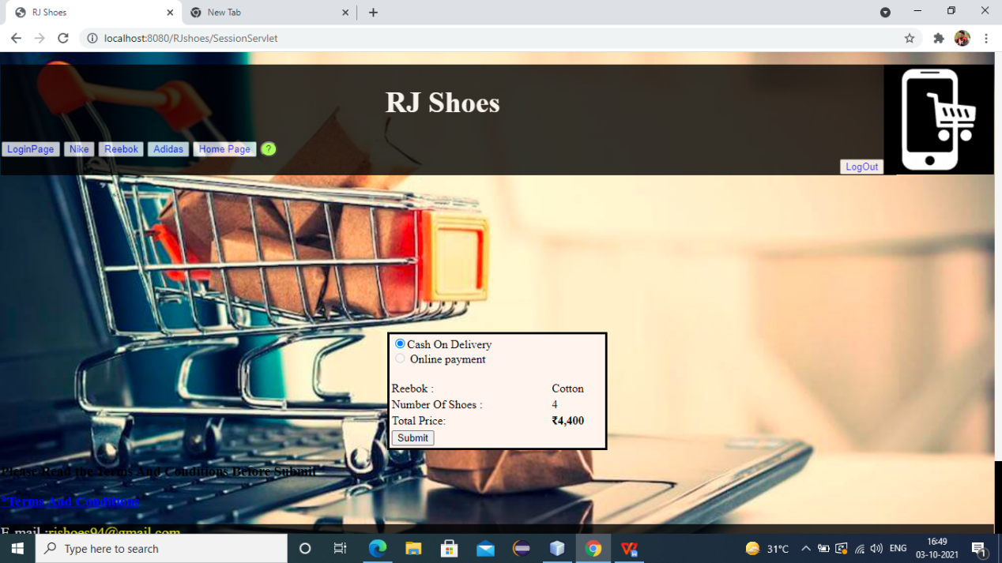

**ADIDAS.JSP**

<%--

Document : Adidas

Created on : Sep 1, 2021, 10:40:06 AM

Author : RAJA M

--%>

<%@page contentType="text/html" pageEncoding="UTF-8"%>

<%@taglib prefix="c" uri="http://java.sun.com/jsp/jstl/core"%>

<!DOCTYPE html>

<html>

<jsp:include page="header.jsp"></jsp:include>

<jsp:include page="Template.jsp"></jsp:include>

<head>

<meta http-equiv="Content-Type" content="text/html; charset=UTF-8">

<title>RJ Shoes</title>

</head>

<body>

<center>

<form action='<c:url value="/SessionServlet"/>' name="myform" method="post">

<table style="border: none; border-spacing: 50px; background-color: darkorange; opacity: 0.7"><tr>

<td><img src='Images/Adidas/Adidas1.jpg' name="adidas" value="Track" width='100' height='100'/>

<details><c:set var="Track" value="1500"/>Price : <c:out value="${Track}"/><br>

<c:set var="Track" value="Track"/>Name : <c:out value="${Track}"/></details><br/></td>

<td><img src='Images/Adidas/Adidas2.jpg' name="adidas" value="Darkspot" width='100' height='100' />

<details><c:set var="Darkspot" value="1600"/>Price : <c:out value="${Darkspot}"/><br>

<c:set var="Darkspot" value="Darkspot"/>Name : <c:out value="${Darkspot}"/></details><br/></td>

<td><img src='Images/Adidas/Adidas3.jpg' name="adidas" value="Radoone" width='100' height='100'/>

<details><c:set var="Radoone" value="1700"/>Price : <c:out value="${Radoone}"/><br>

<c:set var="Radoone" value="Radoone"/>Name : <c:out value="${Radoone}"/></details><br/></td>

<td><img src='Images/Adidas/Adidas4.jpeg' name="adidas" value="Maskoff" width='100' height='100'/>

<details><c:set var="Maskoff" value="1800"/>Price : <c:out value="${Maskoff}"/><br>

<c:set var="Maskoff" value="Maskoff"/>Name : <c:out value="${Maskoff}"/></details><br/></td>

<td><img src='Images/Adidas/Adidas5.jpg' name="adidas" value="Navigate" width='100' height='100'/>

<details><c:set var="Navigate" value="1900"/>Price : <c:out value="${Navigate}"/><br>

<c:set var="Navigate" value="Navigate"/>Name : <c:out value="${Navigate}"/></details><br/></td>

<td><img src='Images/Adidas/Adidas6.jpg' name="adidas" value="Toolkit" width='100' height='100'/>

<details><c:set var="Toolkit" value="2000"/>Price : <c:out value="${Toolkit}"/><br>

<c:set var="Toolkit" value="Toolkit"/>Name : <c:out value="${Toolkit}"/></details><br/></td>

<td><img src='Images/Adidas/Adidas7.jpg' name="adidas" value="Sprintrock" width='100' height='100'/>

<details><c:set var="Sprintrock" value="2100"/>Price : <c:out value="${Sprintrock}"/><br>

<c:set var="Sprintrock" value="Sprintrock"/>Name : <c:out value="${Sprintrock}"/></details><br/></td>

<td><img src='Images/Adidas/Adidas8.jpeg' name="adidas" value="Macraw" width='100' height='100'/>

<details><c:set var="Macraw" value="2200"/>Price : <c:out value="${Macraw}"/><br>

<c:set var="Macraw" value="Macraw"/>Name : <c:out value="${Macraw}"/></details><br/></td>

</tr></table></form>

<br><br><br><br><br>

<form action='<c:url value="/SessionServlet"/>' name='MyForm' method='POST'>

<table style="border: solid seashell; border-spacing: 15px; opacity: 1; background-color: seashell"> <tr>

<td bordercolor='white'><font color='darkorange'> Select Item From Above : </font></td>

<td bordercolor='white'>

<select name='adidas'>

<option value='Track'>Track</option>

<option value='Darkspot'>Darkspot</option>

<option value='Radoone'>Radoone</option>

<option value='Maskoff'>Maskoff</option>

<option value='Navigate'>Navigate</option>

<option value='Toolkit'>Toolkit</option>

<option value='Sprintrock'>Sprintrock</option>

<option value='Macraw'>Macraw</option>

</select>

<tr>

<td bordercolor='white'><font color='darkorange'> Number of Shoes: </font> </td>

<td bordercolor='white'>

<input type= 'text' name='numOfadidas' required="" autofocus=""></td> </tr> <tr><td allign="center">

<font color='darkorange'>Delivery Address : </font><br><textarea name="Delivery Address" rows="3" cols="20" required=""></textarea><br/><br/>

<input type='hidden' value='yadidas' name='PageName'/> </td> </tr> <tr>

<td bordercolor='white'>

<input type='submit' Value='Next'></input></td>

</tr></table></form>

</center>

</body>

<jsp:include page="footer.jsp"></jsp:include>

</html>

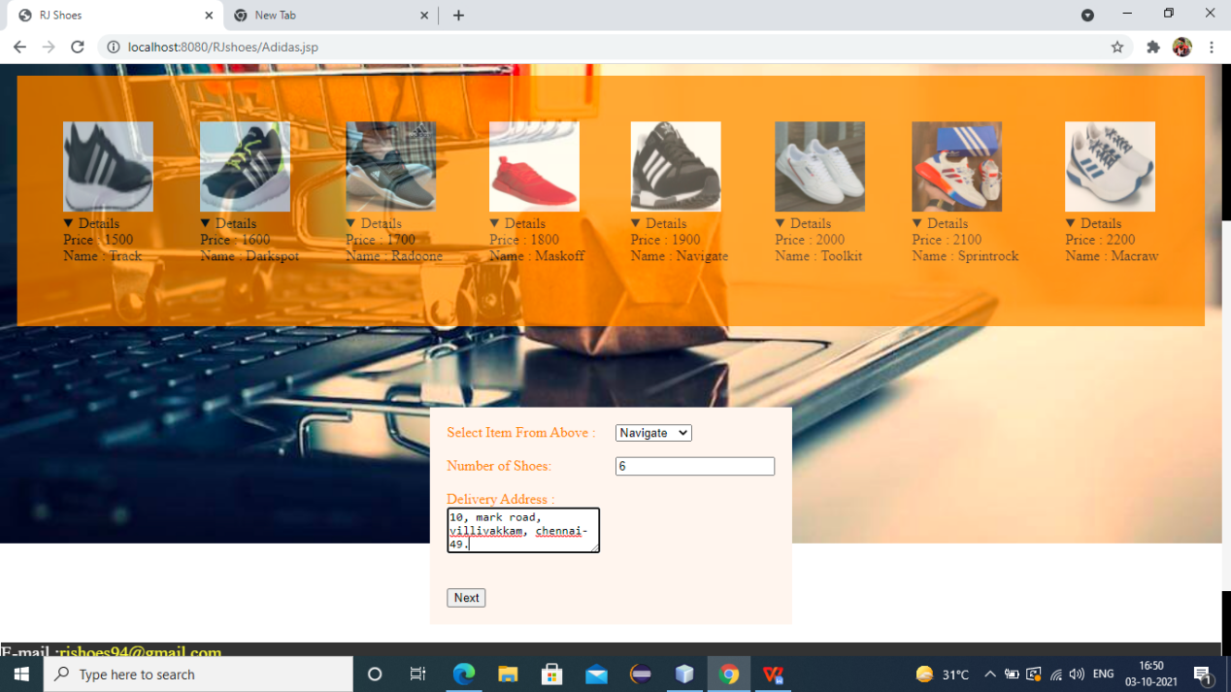

**ADIDASDETAILS.JSP**

<%--

Document : Adidasdetails

Created on : Sep 10, 2021, 9:08:48 PM

Author : RAJA M

--%>

<%@page contentType="text/html" pageEncoding="UTF-8"%>

<%@taglib prefix="c" uri="http://java.sun.com/jsp/jstl/core"%>

<%@taglib prefix="fmt" uri="http://java.sun.com/jsp/jstl/fmt" %>

<!DOCTYPE html>

<html>

<jsp:include page="header.jsp"></jsp:include>

<jsp:include page="Template.jsp"></jsp:include>

<head>

<meta http-equiv="Content-Type" content="text/html; charset=UTF-8">

<title>RJ Shoes</title>

</head>

<body>

<center>

<form action="OrderPlaced.jsp" method="post">

<table style="color: black; border: 3px solid; width: 300px; height: 160px; background-color: seashell" ><tr><td>

<input type="radio" name="bt" value="cash" checked="checked" />Cash On Delivery<br>

<input type="radio" name="bt" value="online" disabled="disabled" /> Online payment<br/><br/>

</td></tr>

<c:set var="adidas" value="${sessionScope.seladidas}"/>

<c:set var="NumberOfAdidas" value="${numadidas}"/>

<c:choose>

<c:when test="${adidas=='Track'}">

<c:set var="Price" value="1500"/>

</c:when>

<c:when test="${adidas=='Darkspot'}">

<c:set var="Price" value="1600"/>

</c:when>

<c:when test="${adidas=='Radoone'}">

<c:set var="Price" value="1700"/>

</c:when>

<c:when test="${adidas=='Maskoff'}">

<c:set var="Price" value="1800"/>

</c:when>

<c:when test="${adidas=='Navigate'}">

<c:set var="Price" value="1900"/>

</c:when>

<c:when test="${adidas=='Toolkit'}">

<c:set var="Price" value="2000"/>

</c:when>

<c:when test="${adidas=='Sprintrock'}">

<c:set var="Price" value="2100"/>

</c:when>

<c:when test="${adidas=='Macraw'}">

<c:set var="Price" value="2200"/>

</c:when>

</c:choose>

<tr><td bordercolor='white'>Adidas : <td colspan="2"><c:out value="${adidas}"/> </td><br>

<br>

<tr><td bordercolor='Black'>Number Of Shoes : <td colspan="2"><c:out value="${NumberOfAdidas}"/></td> <br>

<tr><td bordercolor='Black'>Total Price: <td colspan="2"><b><fmt:formatNumber pattern="₹##,##,###.##" value="${Price*NumberOfAdidas}"/></b></td><br><br/>

<tr>

<td><input type="submit" value="Submit" /></td></tr>

</table>

</form>

</center>

</body>

<jsp:include page="footer.jsp"></jsp:include>

</html>

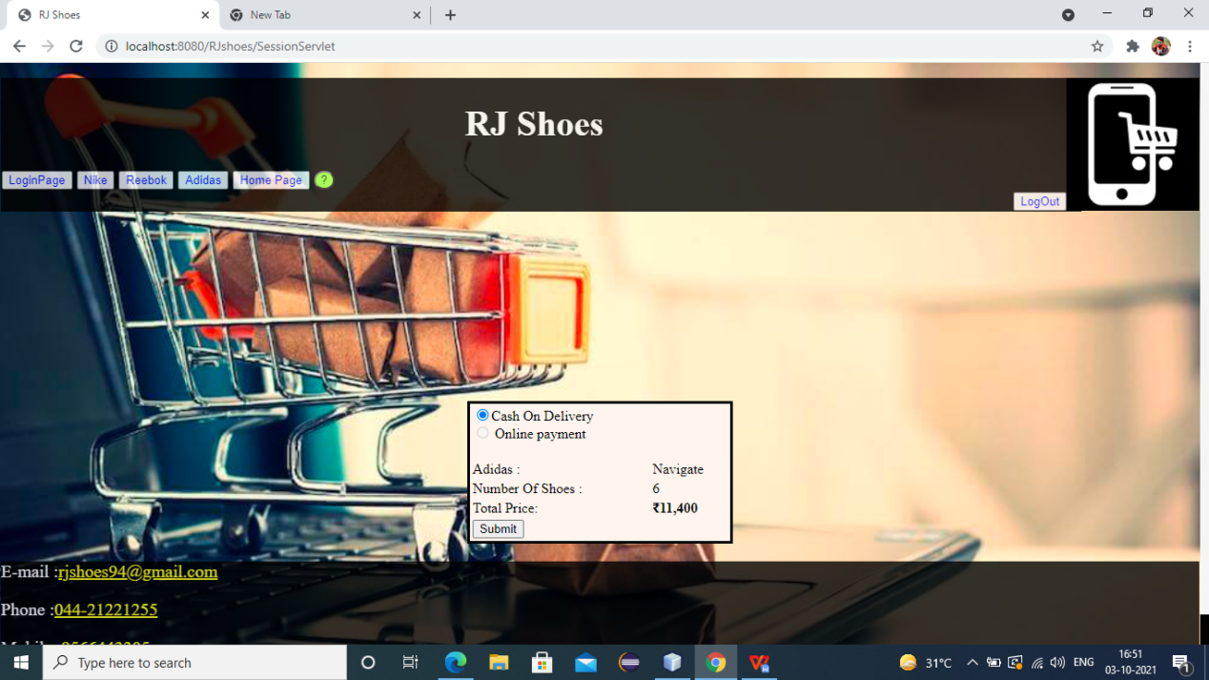

**LOGINDAO.JAVA**

package control;

import java.io.IOException;

import java.io.PrintWriter;

import java.sql.Connection;

import java.sql.DriverManager;

import java.sql.PreparedStatement;

import java.sql.ResultSet;

import java.sql.SQLException;

import javax.servlet.RequestDispatcher;

import javax.servlet.ServletException;

import javax.servlet.annotation.WebServlet;

import javax.servlet.http.HttpServlet;

import javax.servlet.http.HttpServletRequest;

import javax.servlet.http.HttpServletResponse;

/**

*

* @author RAJA M

*/

@WebServlet(name = "Logindao", urlPatterns = {"/Logindao"})

public class Logindao extends HttpServlet {

protected void processRequest(HttpServletRequest request, HttpServletResponse response)

throws ServletException, IOException {

response.setContentType("text/html;charset=UTF-8");

try (PrintWriter out = response.getWriter()) {

}

}

@Override

protected void doPost(HttpServletRequest request, HttpServletResponse response)

throws ServletException, IOException {

PrintWriter out = response.getWriter();

String uname=request.getParameter("user");

String npass=request.getParameter("pass");

try{

Class.forName("org.apache.derby.jdbc.ClientDriver");

Connection con=DriverManager.getConnection("jdbc:derby://localhost:1527/Raja","Raja","12345");

System.out.println("connected using Login page");

String sql="select * from RAJA.REGISTRATION where uname=? and npass=?";

PreparedStatement ps=con.prepareStatement(sql);

ps.setString(1, uname);

ps.setString(2, npass);

String unameDB="";

String npassDB="";

ResultSet rs=ps.executeQuery();

if(rs.next())

{

unameDB=rs.getString("uname");

npassDB=rs.getString("npass");

if((uname.equals(unameDB))&&(npass.equals(npassDB))){

RequestDispatcher rd=request.getRequestDispatcher("WelcomeCostumer.jsp");

rd.forward(request, response);

}

}

else{

RequestDispatcher rd=request.getRequestDispatcher("LoginPage.jsp");

out.println("<!DOCTYPE html>");

out.println("<html>");

out.println("<head>");

out.println("</head>");

out.println("<body>");

out.println("<center>");

out.println("<h2 style='color: red'>UserName Or Password Error</h2>");

out.println("</center>");

out.println("</body>");

out.println("</html>");

rd.include(request, response);

}

}catch(ClassNotFoundException | SQLException e){

System.out.println("Error From Login : "+e.getMessage());

}

}

}

**SESSIONSERVLET.JAVA**

package control;

import java.io.IOException;

import java.io.PrintWriter;

import javax.servlet.RequestDispatcher;

import javax.servlet.ServletException;

import javax.servlet.annotation.WebServlet;

import javax.servlet.http.HttpServlet;

import javax.servlet.http.HttpServletRequest;

import javax.servlet.http.HttpServletResponse;

import javax.servlet.http.HttpSession;

/**

*

* @author RAJA M

*/

@WebServlet(name = "SessionServlet", urlPatterns = {"/SessionServlet"})

public class SessionServlet extends HttpServlet {

protected void processRequest(HttpServletRequest request, HttpServletResponse response)

throws ServletException, IOException {

response.setContentType("text/html;charset=UTF-8");

try (PrintWriter out = response.getWriter()) {

HttpSession session = request.getSession(false);

String requestingPageName = request.getParameter("PageName");

switch (requestingPageName) {

case "ynike":

{

String selectednike = request.getParameter("nike");

String noOfnikes = request.getParameter("numOfNikes");

session.setAttribute("selnike", selectednike);

session.setAttribute("numnikes", noOfnikes);

RequestDispatcher dispatch = request.getRequestDispatcher("Nikedetails.jsp");

dispatch.forward(request, response);

break;

}

case "yreebok":

{

String selectedreebok = request.getParameter("reebok");

String noOfreebok = request.getParameter("numOfReebok");

session.setAttribute("selreebok", selectedreebok);

session.setAttribute("numreebok", noOfreebok);

RequestDispatcher dispatch = request.getRequestDispatcher("Reebokdetails.jsp");

dispatch.forward(request, response);

break;

}

case "yadidas":

{

String selectedadidas = request.getParameter("adidas");

String noOfadidas = request.getParameter("numOfadidas");

session.setAttribute("seladidas", selectedadidas);

session.setAttribute("numadidas", noOfadidas);

RequestDispatcher dispatch = request.getRequestDispatcher("Adidasdetails.jsp");

dispatch.forward(request, response);

break;

}

default:

{

RequestDispatcher dispatch = request.getRequestDispatcher("Error.jsp");

dispatch.forward(request, response);

break;

}

}

}

}

@Override

protected void doGet(HttpServletRequest request, HttpServletResponse response)

throws ServletException, IOException {

processRequest(request, response);

}

@Override

protected void doPost(HttpServletRequest request, HttpServletResponse response)

throws ServletException, IOException {

processRequest(request, response);

}

@Override

public String getServletInfo() {

return "Short description";

}// </editor-fold>

}

**REGISTRATIONDAO.JAVA**

package control;

import java.io.IOException;

import static java.lang.System.out;

import java.sql.Connection;

import java.sql.DriverManager;

import java.sql.PreparedStatement;

import java.sql.SQLException;

import javax.servlet.RequestDispatcher;

import javax.servlet.ServletException;

import javax.servlet.annotation.WebServlet;

import javax.servlet.http.HttpServlet;

import javax.servlet.http.HttpServletRequest;

import javax.servlet.http.HttpServletResponse;

/**

*

* @author RAJA M

*/

@WebServlet(name = "registrationdao", urlPatterns = {"/registrationdao"})

public class registrationdao extends HttpServlet {

protected void processRequest(HttpServletRequest request, HttpServletResponse response)

throws ServletException, IOException {

response.setContentType("text/html;charset=UTF-8");

// Statement st=null;

// String mg="";

String uname=request.getParameter("username");

String email=request.getParameter("email");

String npass=request.getParameter("npass");

String rpass=request.getParameter("rpass");

String address=request.getParameter("Address");

String state=request.getParameter("State");

String phone=request.getParameter("phone");

try {

Connection con;

Class.forName("org.apache.derby.jdbc.ClientDriver");

con=DriverManager.getConnection("jdbc:derby://localhost:1527/Raja","Raja","12345");

System.out.println("connected");

String sql = "insert into RAJA.REGISTRATION(uname,email,npass,rpass,address,state,phone) values(?,?,?,?,?,?,?)";

PreparedStatement ps=con.prepareStatement(sql);

ps.setString(1, uname);

ps.setString(2, email);

ps.setString(3, npass);

ps.setString(4, rpass);

ps.setString(5, address);

ps.setString(6, state);

ps.setString(7, phone);

if(npass.equals(rpass))

{

ps.executeUpdate();

RequestDispatcher rds=request.getRequestDispatcher("LoginPage.jsp");

rds.forward(request, response);

}

else{

RequestDispatcher rds=request.getRequestDispatcher("Error.jsp");

rds.include(request, response);

}

}

catch(ClassNotFoundException | SQLException e){

out.println("Error in DB : "+e.getMessage());

}

}

@Override

protected void doGet(HttpServletRequest request, HttpServletResponse response)

throws ServletException, IOException {

processRequest(request, response);

}

@Override

protected void doPost(HttpServletRequest request, HttpServletResponse response)

throws ServletException, IOException {

processRequest(request, response);

}

@Override

public String getServletInfo() {

return "Short description";

}// </editor-fold>

}

**REGISTERVAL.JAVA**

/*

* To change this license header, choose License Headers in Project Properties.

* To change this template file, choose Tools | Templates

* and open the template in the editor.

*/

package control;

import java.io.IOException;

import java.io.PrintWriter;

import javax.servlet.RequestDispatcher;

import javax.servlet.ServletException;

import javax.servlet.annotation.WebServlet;

import javax.servlet.http.HttpServlet;

import javax.servlet.http.HttpServletRequest;

import javax.servlet.http.HttpServletResponse;

/**

*

* @author RAJA M

*/

@WebServlet(name = "Registerval", urlPatterns = {"/Registerval"})

public class Registerval extends HttpServlet {

protected void processRequest(HttpServletRequest request, HttpServletResponse response)

throws ServletException, IOException {

response.setContentType("text/html;charset=UTF-8");

try (PrintWriter out = response.getWriter()) {

String np=request.getParameter("npass");

String rp=request.getParameter("rpass");

Register res=new Register(np,rp);

if(res.val())

{

RequestDispatcher rd=request.getRequestDispatcher("LoginPage.jsp");

out.println("<br><br><br><br>");

out.println("<center>");

out.println("<h2 style='color: #00cccc'>Registration Successfull</h2>");

out.println("</center>");

rd.include(request, response);

}

else

{

RequestDispatcher rd=request.getRequestDispatcher("Registration.jsp");

out.println("<br><br><br><br>");

out.println("<center>");

out.println("<h2 style='color: red'>Password Error</h2>");

out.println("</center>");

rd.include(request, response);

}

}

}

@Override

protected void doGet(HttpServletRequest request, HttpServletResponse response)

throws ServletException, IOException {

processRequest(request, response);

}

@Override

protected void doPost(HttpServletRequest request, HttpServletResponse response)

throws ServletException, IOException {

processRequest(request, response);

}

@Override

public String getServletInfo() {

return "Short description";

}// </editor-fold>

}

**LOGOUT.JAVA**

package control;

import java.io.IOException;

import java.io.PrintWriter;

import javax.servlet.RequestDispatcher;

import javax.servlet.ServletException;

import javax.servlet.annotation.WebServlet;

import javax.servlet.http.HttpServlet;

import javax.servlet.http.HttpServletRequest;

import javax.servlet.http.HttpServletResponse;

import javax.servlet.http.HttpSession;

/**

*

* @author RAJA M

*/

@WebServlet(name = "Logout", urlPatterns = {"/Logout"})

public class Logout extends HttpServlet {

protected void processRequest(HttpServletRequest request, HttpServletResponse response)

throws ServletException, IOException {

response.setContentType("text/html;charset=UTF-8");

try (PrintWriter out = response.getWriter()) {

}

}

@Override

protected void doGet(HttpServletRequest request, HttpServletResponse response)

throws ServletException, IOException {

HttpSession hs=request.getSession();

hs.invalidate();

response.sendRedirect("LoginPage.jsp");

}

@Override

protected void doPost(HttpServletRequest request, HttpServletResponse response)

throws ServletException, IOException {

processRequest(request, response);

}

@Override

public String getServletInfo() {

return "Short description";

}// </editor-fold>

}

**TEMPLATE.JSP**

<%--

Document : Template

Created on : Aug 29, 2021, 11:11:25 AM

Author : RAJA M

--%>

<%@page contentType="text/html" pageEncoding="UTF-8"%>

<!DOCTYPE html>

<html>

<head>

<meta http-equiv="Content-Type" content="text/html; charset=UTF-8">

<title>RJ Shoes</title>

</head>

<body>

<style>

body{

margin: auto;

border: 1px solid transparent;

background-image: url('Images/Back2.jpg');

background-repeat: no-repeat;

background-size: 100%;

}

</style>

<style>

::-webkit-scrollbar{

width: 10px;

}

::-webkit-scrollbar-track{

background: black;

}

::-webkit-scrollbar-thumb{

background: whitesmoke;

}

::-webkit-scrollbar-thumb:hover{

background: #ffff99;

}

</style>

</body>

</html>

**HEADER.JSP**

<%--

Document : header

Created on : Sep 6, 2021, 1:01:08 PM

Author : RAJA M

--%>

<%@page contentType="text/html" pageEncoding="UTF-8"%>

<!DOCTYPE html>

<html>

<head>

<meta http-equiv="Content-Type" content="text/html; charset=UTF-8">

<title>RJ Shoes</title>

<style>

.header{

top: 0;

width: 90%;

text-align: left;

font-size: 20px;

background-color: black;

color: white;

padding: 1px;

opacity: 0.8;

}

</style>

</head>

<body>

<p>

<img src="Images/logo.jpg" style="float: right; width: 150px; height: 150px;">

<div class="header">

<h1 style="color: whitesmoke; text-align: center">RJ Shoes</h1>

<a href="LoginPage.jsp"><input type="submit" value="LoginPage" style="color: blue"/></a>

<a href="Nike.jsp"><input type="submit" value="Nike" style="color: blue"/></a>

<a href="Reebok.jsp"><input type="submit" value="Reebok" style="color: blue"/></a>

<a href="Adidas.jsp"><input type="submit" value="Adidas" style="color: blue"/></a>

<a href="WelcomeCostumer.jsp"><input type="submit" value="Home Page" style="color: blue"/></a>

<input type="submit" value="?" style="background-color: greenyellow; border-radius: 50%"onclick="document.getElementById('help').style.display='block'" />

<div align="right">

<a href="Logout"><input type="submit" value="LogOut" style="color: blue"/></a>

</div>

</div>

</p>

</body>

<br><br><br><br><br><br>

</html>

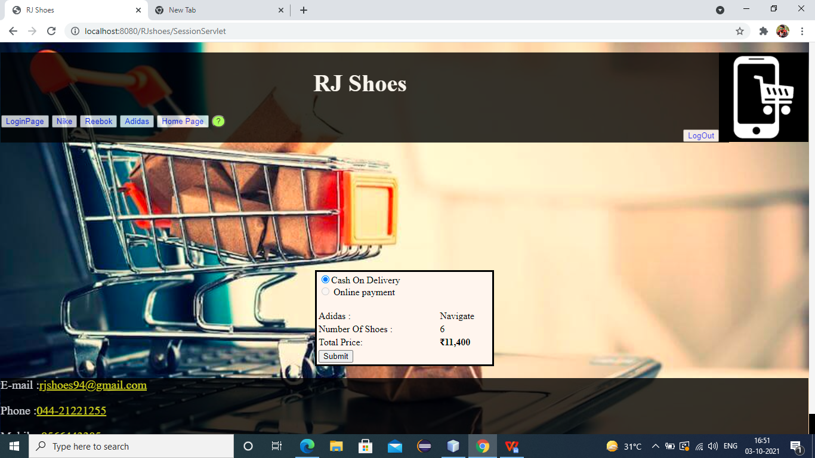

**FOOTER.JSP**

<%--

Document : footer

Created on : Sep 4, 2021, 12:53:05 PM

Author : RAJA M

--%>

<%@page contentType="text/html" pageEncoding="UTF-8"%>

<!DOCTYPE html>

<html>

<head>

<meta http-equiv="Content-Type" content="text/html; charset=UTF-8">

<title>RJ Shoes</title>

<style>

.footer{

margin: 0;

bottom: 0;

text-align: left;

font-size: 20px;

background-color: black;

color: white;

opacity: 0.8;

}

</style>

</head>

<body>

<div class="footer">

<p>E-mail :<a href="mailto:rjshoes94@gmail.com" style="color: yellow">rjshoes94@gmail.com</a></p>

<p>Phone :<a href="tel:044-21221255" style="color: yellow">044-21221255</a></p>

<p>Mobile :<a href="9566443305" style="color: yellow">9566443305</a></p>

</div>

</body>

</html>



**DATABASE**

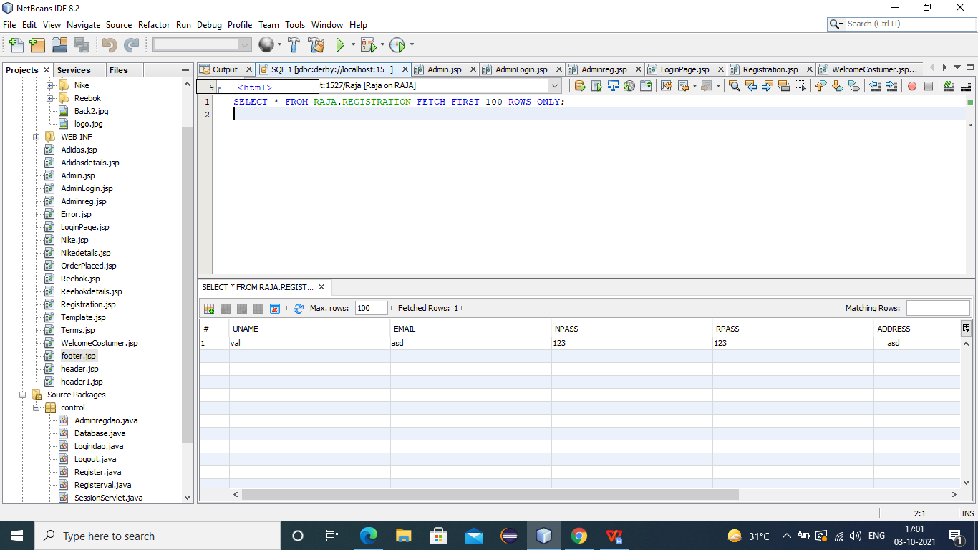

**Conclusion**

This is a simple online shoe shopping project using Java, HTML and CSS. Also using database to save data for customer registration.